**YI Chung-sŏp (이중섭, 李仲燮, 1916-1956)**

Yi Chung-sŏp was a modern Korean painter known for his Expressionist style. Yi's painting was strongly influenced by brushwork of Korean painting and calligraphy but also by the bold black contours of George Rouault (1871-1958), to the extent that Yi was called "Bunka’s Rouault." Born in P’yŏngyang in Northern Korea, a city known for its historical and cultural relics, Yi attended the nationalistic Osan High School where he studied art under Im Yong-ryŏn (임용련, 任用璉, born 1901), a Western-style painter who had worked in the US during the 1920s. In 1937, Yi went to Tokyo, where he entered the private Imperial Art School (now Musashino Art School) and then the Cultural School(*Bunka Gakuin*). At the latter, Yi studied with Tsuda Seishu (1907-1952), an avant-garde artist who helped Yi to realize the value of Korean traditional aesthetics and who encouraged him to integrate a Korean spirit into his art. Yi then returned to Korea, staying on the northeastern coast of Wŏnsan with his Japanese wife and two sons. With the advent of the Korean War in 1950, Yi fled to south with his family. In the following years, despite Yi's financial and psychological difficulties, he produced a large number of works in Expressionist style.

While in Japan, Yi was active in such avant-garde exhibitions as *Dokuritsuten* and *Jiyuten* from 1938 to 1943, winning recognition in the main art circles in Tokyo. In 1941, Yi joined several other Korean artists active in Tokyo to establish the strongly nationalistic Chosŏn New Artist Society (*Chosŏn Shinmisulga Hyŏphŏe*). Once he returned to Korea, Yi suffered from extreme poverty as a result of the Korean War, to the extent that he could not support his family who then went back to Japan.

The most frequent subject of his later expressionistic paintings was a bull, painted in yellow, red, white, or black. Yi had closely observed this animal in his hometown and his angry and distorted bulls came to reflect his own struggles and the struggles of his country. This is apparent in the case of his work *White bull* painted right after the Korean War, which features a craggy, wiry bull in vigorous white brushstrokes on a black ground. During this period, Yi was also unable to acquire proper painting materials, instead using nails and the tinfoil from cigarette cases to make line drawings of his family often in the nude. He also drew playful children and in addition to bulls, other animals such as chickens, fish, and birds, which often appear intermingled together in his paintings. While he was living alone at southern-most Cheju island and Pusan in Korea Yi also made allegorical drawings and paintings that seem to address his love for his family and his hope for a remote and unobtainable utopia. He continued to exhibit throughout the 1940s and 50s, mainly in group shows. His first and last solo exhibition was held in a department store in Seoul in 1955.

Longing for his family, lonely, and tortured, Yi eventually broke down mentally and physically. He died alone at a hospital in Seoul.

**References and Further Reading**

Kim, Youngna. (1998) "Modern Korean painting and sculpture," in John Clark, ed. *Modern Asian Art*. Honolulu: University of Hawai’i Press, 155-168.

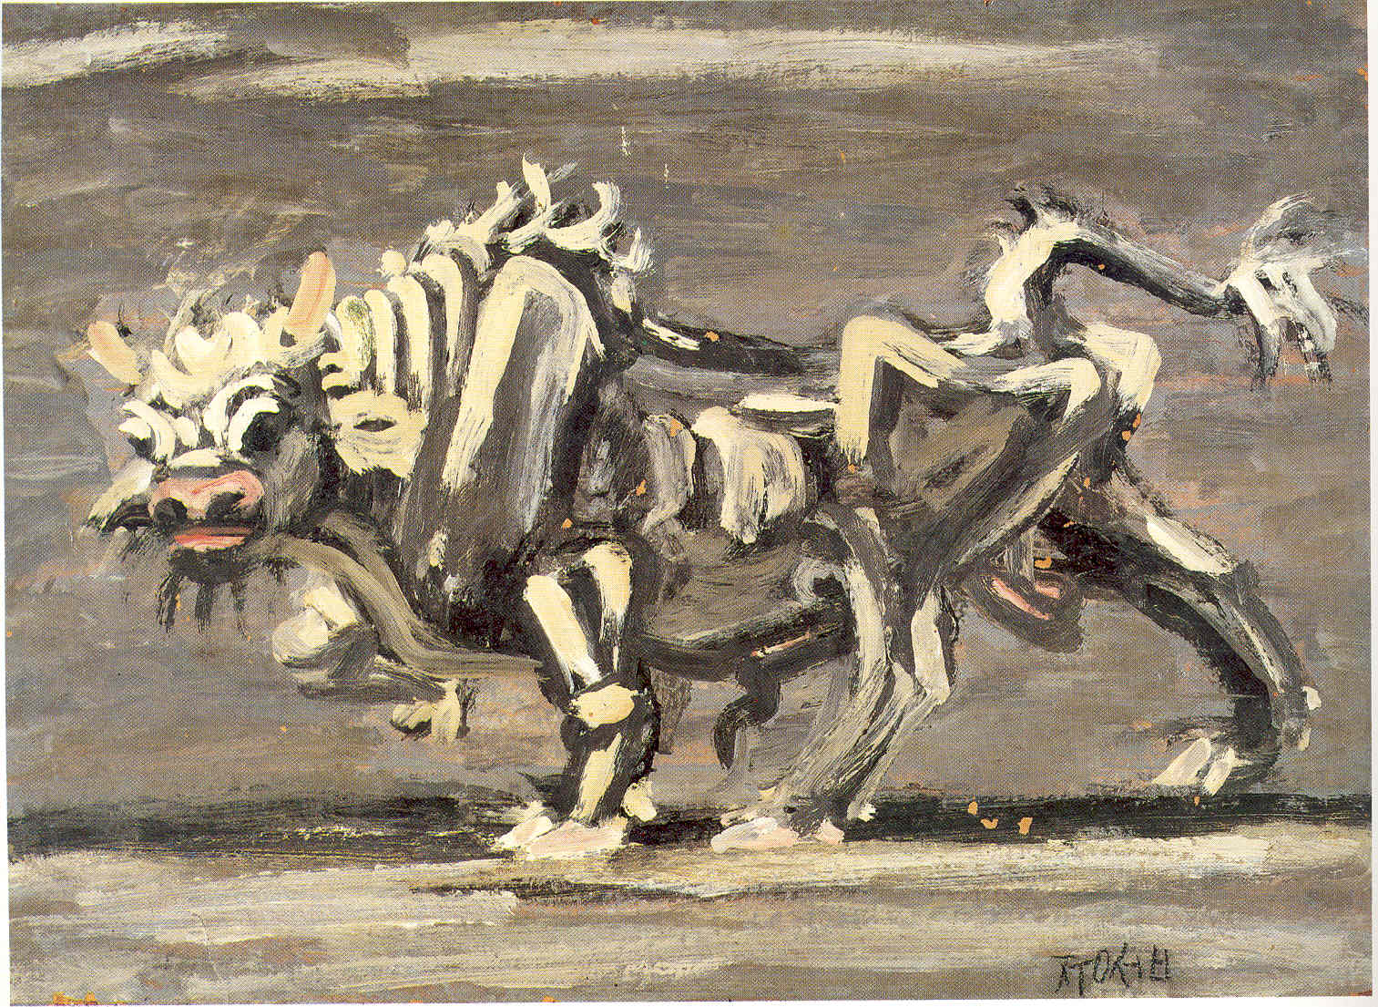

Yi Chung-sŏp, *White bull*, c.1953-4. Oil on Paper, 30x41.7cm, Hongik University Museum of Art.